**KARNATAK LAW SOCIETY’S**

**GOGTE INSTITUTE OF TECHNOLOGY**

UDYAMBAG, BELAGAVI-590008

(An Autonomous Institution under Visvesvaraya Technological University, Belagavi)

**(APPROVED BY AICTE, NEW DELHI)**



*Course Activity Report*

**“TIC-TAC-TOE GAME”**

*Submitted in the partial fulfillment for the academic requirement of*

***7 Semester B.E. in***

*Computer Science Engineering*

*Submitted by*

**NAME USN**

1. Tanuja Bhajantri 2GI19CS164
2. Usha Ugar 2GI19CS169
3. Netravati Milli 2GI20CS408
4. Varsha vallyapur 2GI20CS419

**UNDER THE GUIDENCE OF**

**Asst. Prof Prasad Pujeri**

**Dept of Computer Science engineering**

**2022 – 2023**

KARNATAK LAW SOCIETY’S

**GOGTE INSTITUTE OF TECHNOLOGY**

UDYAMBAG, BELAGAVI-590008

(An Autonomous Institution under Visvesvaraya Technological University, Belagavi)

**(APPROVED BY AICTE, NEW DELHI)**

Department of Computer Science Engineering

 

**CERTIFICATE**

This is to certify that Mr./Ms. **Tanuja ,Usha , Netravati and Varsha** of **7** semester and bearing USN **2GI19CS164 , 2GI19CS169, 2GI20CS408, 2GI20CS419** has satisfactorily completed the course activity (Seminar/Project) in **MOBILE APPLICATION DEVELOPMENT LABORATORY** course. It can be considered as a bonafide work carriedoutin partial fulfillment for the academic requirement of **7** Semester B.E. (Computer Science Engineering) prescribed by KLS Gogte Institute of Technology, Belagavi during the academic year 2022 – 2023.

The report has been approved as it satisfies the academic requirements in respect of Assignment (Course activity) prescribed for the said Degree.

Signature of the Faculty Member        Signature of the HOD

Date: 04-01-2023

**Marks allocation:**

|  |  |  |  |  |  |  |
| --- | --- | --- | --- | --- | --- | --- |
|  | Batch No.: 7 | | | | | |
| 1. | Seminar/Project Title:  **Develop Quiz Application** | Marks Range | USN/Roll No | | | |
| 2GI19CS164 | 2GI19CS169 | 2GI20CS408 | 2GI20CS419 |
| 2. | Abstract (PO2) | 0-2 |  |  |  |  |
| 3. | Application of the topic to the course (PO2) | 0-3 |  |  |  |  |
| 4. | Literature survey and its findings (PO2) | 0-4 |  |  |  |  |
| 5. | Methodology, Results and Conclusion (PO1, PO3, PO4) | 0-6 |  |  |  |  |
| 6. | Report and Oral presentation skill (PO9, PO10) | 0-5 |  |  |  |  |
|  | Total | 20 |  |  |  |  |

**\* 20 marks is converted to 10 marks for CGPA calculation**

**1.Engineering Knowledge:** Apply the knowledge of mathematics, science, engineering fundamentals and an engineering specialization to the solution of complex engineering problems.

**2.Problem Analysis:** Identify, formulate, review research literature, and analyze complex engineering problems reaching substantiated conclusions using first principles of mathematics, natural sciences and Engineering sciences.

**3.Design/Development of solutions:**Design solutions for complex engineering problems and design system components or processes that meet the specified needs with appropriate consideration for the public health and safety, and the cultural, societal, and environmental considerations.

**4.Conduct investigations of complex problems:** Use research-based knowledge and research methods including design of experiments, analysis and interpretation of data, and synthesis of the information to provide valid conclusions.

**5.Modern tool usage:**Create, select, and apply appropriate techniques, resources, and modern engineering and IT tools including prediction and modeling to complex engineering activities with an understanding of the limitations.

**6.The engineer and society:**Apply reasoning informed by the contextual knowledge to assess societal, health, safety, legal and cultural issues and the consequent responsibilities relevant to the professional engineering practice.

**7.Environment and sustainability:** Understand the impact of the professional engineering solutions in societal and environmental contexts, and demonstrate the knowledge of, and need

for sustainable development.

**8.Ethics:** Apply ethical principles and commit to professional ethics and responsibilities and norms of the engineering practice.

**9.Individual and team work:** Function effectively as an individual and as a member or leader in diverse teams, and in multidisciplinary settings.

**10.Communication:** Communicate effectively on complex engineering activities with the engineering community and with society at large, such as, being able to comprehend and write effective reports and design documentation, make effective presentations, and give and receive clear instructions.

**11. Project management and finance:** Demonstrate knowledge and understanding of the engineering management principles and apply these to one's own work, as a member and leader in a team, to manage projects and in multidisciplinary environments.

**12. Life-long learning:** Recognize the need for and have the preparation and ability to engage in independent and lifelong learning in the broadest context of technological channel

**CONTENT**

1. Introduction
2. Problem statement for the project
3. Overview
4. Purpose
5. System Requirements
6. Application and Technologies used
7. Source Code and Outputs
8. Conclusion
9. References

**INTRODUCTION**

This is a simply and beautify android tic-tac-toe game application . We will building tic-tac-toe game project using Java and XML in Android.The tic-tac-toe game is based on a two player game.The game is played on three by three board .Each player has a marker. One player has an ‘X’, the other an ‘O’. Player play one move at atime simultaneously.In a move, a player can choose any position from a 3x3 grid.

**PROBLEM DEFINITION**

Create a TIC-TAC-TOE GAME application using in Android Studio.

**OVERVIEW**

In today’s world, Smart phones have changed our lives and have become an indispensable part of our lives because of its specialty to simplify our routine work and thereby saving our time. A Smartphone with an Android OS offers excellent functionality to the users offering a distinct experience. Android is a Linux based operating system and it was bought by Google in 2007.There are tons of application available and one of the prime reasons for this vast number is android being an open source. On the other hand, android based device like mobile, tab are very user friendly. A survey has done by “Light Castle Partners” research wing which indicates that though other operating system mobile users exist but the majority users are goes with android operating system. In this context, Project application is developed based on android platform. The name of application is defined as ‘TIC TAC TOE GAME’.

**PURPOSE**

This document provides a base to all the functionalities which should be carried out by the application, how that works the outputs available to the end user.

**SYSTEM REQUIREMENTS**

1. Smartphone with Android OS version 4.4 (KitKat) or higher
2. Minimum 512 MB of RAM.
3. A processor with speeds above 1.2 GHz (any make).
4. 16 MB of storage for the app and extra for the data stored, the size of the app increases as the number of entries are increased.
5. Android API version 19.
6. Permission to install applications over USB and installation from unknown sources from ‘Developer Options’

**APPLICATIONS AND TECHNOLOGY USED**

1. **Android Studio**: Android studio is the official Integrated Development Environment (IDE) for designing, coding, debugging and executing applications for Google’s Smartphone operating system, 8 Android. It has all keywords inbuilt for ease in backend programming and also design statements, for ease in designing as well. The version of Android Studio used to design the application is 1.4.1.to 3.1 as we are working on studios 3.1.

2. **Java Development Kit (JDK)**: Since, Android applications require Java programming for its backend programming; it needs a JAVA environment to support its functions, executions and syntax.

3. **Xml:** The frontend design of the application involves xml statements for the Relative layouts, Radio buttons, Radio Group, buttons, text boxes and text views.

**Souce code :**

**XML code:**

|  |
| --- |
| <?xml version="1.0" encoding="utf-8"?>  <vector xmlns:android="http://schemas.android.com/apk/res/android" |
| android:width="108dp" |
| android:height="108dp" |
| android:viewportWidth="108" |
| android:viewportHeight="108"> |
| <path |
| android:fillColor="#3DDC84" |
| android:pathData="M0,0h108v108h-108z" /> |
| <path |
| android:fillColor="#00000000" |
| android:pathData="M9,0L9,108" |
| android:strokeWidth="0.8" |
| android:strokeColor="#33FFFFFF" /> |
| <path |
| android:fillColor="#00000000" |
| android:pathData="M19,0L19,108" |
| android:strokeWidth="0.8" |
| android:strokeColor="#33FFFFFF" /> |
| <path |
| android:fillColor="#00000000" |
| android:pathData="M29,0L29,108" |
| android:strokeWidth="0.8" |
| android:strokeColor="#33FFFFFF" /> |
| <path |
| android:fillColor="#00000000" |
| android:pathData="M39,0L39,108" |
| android:strokeWidth="0.8" |
| android:strokeColor="#33FFFFFF" /> |
| <path |
| android:fillColor="#00000000" |
| android:pathData="M49,0L49,108" |
| android:strokeWidth="0.8" |
| android:strokeColor="#33FFFFFF" /> |
| <path |
| android:fillColor="#00000000" |
| android:pathData="M59,0L59,108" |
| android:strokeWidth="0.8" |
| android:strokeColor="#33FFFFFF" /> |
| <path |
| android:fillColor="#00000000" |
| android:pathData="M69,0L69,108" |
| android:strokeWidth="0.8" |
| android:strokeColor="#33FFFFFF" /> |
| <path |
| android:fillColor="#00000000" |
| android:pathData="M79,0L79,108" |
| android:strokeWidth="0.8" |
| android:strokeColor="#33FFFFFF" /> |
| <path |
| android:fillColor="#00000000" |
| android:pathData="M89,0L89,108" |
| android:strokeWidth="0.8" |
| android:strokeColor="#33FFFFFF" /> |
| <path |
| android:fillColor="#00000000" |
| android:pathData="M99,0L99,108" |
| android:strokeWidth="0.8" |
| android:strokeColor="#33FFFFFF" /> |
| <path |
| android:fillColor="#00000000" |
| android:pathData="M0,9L108,9" |
| android:strokeWidth="0.8" |
| android:strokeColor="#33FFFFFF" /> |
| <path |
| android:fillColor="#00000000" |
| android:pathData="M0,19L108,19" |
| android:strokeWidth="0.8" |
| android:strokeColor="#33FFFFFF" /> |
| <path |
| android:fillColor="#00000000" |
| android:pathData="M0,29L108,29" |
| android:strokeWidth="0.8" |
| android:strokeColor="#33FFFFFF" /> |
| <path |
| android:fillColor="#00000000" |
| android:pathData="M0,39L108,39" |
| android:strokeWidth="0.8" |
| android:strokeColor="#33FFFFFF" /> |
| <path |
| android:fillColor="#00000000" |
| android:pathData="M0,49L108,49" |
| android:strokeWidth="0.8" |
| android:strokeColor="#33FFFFFF" /> |
| <path |
| android:fillColor="#00000000" |
| android:pathData="M0,59L108,59" |
| android:strokeWidth="0.8" |
| android:strokeColor="#33FFFFFF" /> |
| <path |
| android:fillColor="#00000000" |
| android:pathData="M0,69L108,69" |
| android:strokeWidth="0.8" |
| android:strokeColor="#33FFFFFF" /> |
| <path |
| android:fillColor="#00000000" |
| android:pathData="M0,79L108,79" |
| android:strokeWidth="0.8" |
| android:strokeColor="#33FFFFFF" /> |
| <path |
| android:fillColor="#00000000" |
| android:pathData="M0,89L108,89" |
| android:strokeWidth="0.8" |
| android:strokeColor="#33FFFFFF" /> |
| <path |
| android:fillColor="#00000000" |
| android:pathData="M0,99L108,99" |
| android:strokeWidth="0.8" |
| android:strokeColor="#33FFFFFF" /> |
| <path |
| android:fillColor="#00000000" |
| android:pathData="M19,29L89,29" |
| android:strokeWidth="0.8" |
| android:strokeColor="#33FFFFFF" /> |
| <path |
| android:fillColor="#00000000" |
| android:pathData="M19,39L89,39" |
| android:strokeWidth="0.8" |
| android:strokeColor="#33FFFFFF" /> |
| <path |
| android:fillColor="#00000000" |
| android:pathData="M19,49L89,49" |
| android:strokeWidth="0.8" |
| android:strokeColor="#33FFFFFF" /> |
| <path |
| android:fillColor="#00000000" |
| android:pathData="M19,59L89,59" |
| android:strokeWidth="0.8" |
| android:strokeColor="#33FFFFFF" /> |
| <path |
| android:fillColor="#00000000" |
| android:pathData="M19,69L89,69" |
| android:strokeWidth="0.8" |
| android:strokeColor="#33FFFFFF" /> |
| <path |
| android:fillColor="#00000000" |
| android:pathData="M19,79L89,79" |
| android:strokeWidth="0.8" |
| android:strokeColor="#33FFFFFF" /> |
| <path |
| android:fillColor="#00000000" |
| android:pathData="M29,19L29,89" |
| android:strokeWidth="0.8" |
| android:strokeColor="#33FFFFFF" /> |
| <path |
| android:fillColor="#00000000" |
| android:pathData="M39,19L39,89" |
| android:strokeWidth="0.8" |
| android:strokeColor="#33FFFFFF" /> |
| <path |
| android:fillColor="#00000000" |
| android:pathData="M49,19L49,89" |
| android:strokeWidth="0.8" |
| android:strokeColor="#33FFFFFF" /> |
| <path |
| android:fillColor="#00000000" |
| android:pathData="M59,19L59,89" |
| android:strokeWidth="0.8" |
| android:strokeColor="#33FFFFFF" /> |
| <path |
| android:fillColor="#00000000" |
| android:pathData="M69,19L69,89" |
| android:strokeWidth="0.8" |
| android:strokeColor="#33FFFFFF" /> |
| <path |
| android:fillColor="#00000000" |
| android:pathData="M79,19L79,89" |
| android:strokeWidth="0.8" |
| android:strokeColor="#33FFFFFF" /> |
| </vector> |

|  |  |  |
| --- | --- | --- |
| <?xml version="1.0" encoding="utf-8"?> |  |  |
| <RelativeLayout xmlns:android="http://schemas.android.com/apk/res/android" |  |  |
| xmlns:app="http://schemas.android.com/apk/res-auto" |  |  |
| xmlns:tools="http://schemas.android.com/tools" |  |  |
| android:layout_width="match_parent" |  |  |
| android:layout_height="match_parent" |  |  |
| android:padding="16dp" |  |  |
| tools:context=".MainActivity"> |  |  |
|  |  |  |
| <LinearLayout |  |  |
| android:layout_width="match_parent" |  |  |
| android:layout_height="wrap_content" |  |  |
| android:id="@+id/gameLayout" |  |  |
| android:orientation="vertical" |  |  |
| android:layout_centerHorizontal="true" |  |  |
| android:layout_centerVertical="true"> |  |  |
| <LinearLayout |  |  |
| android:layout_width="match_parent" |  |  |
| android:layout_height="wrap_content" |  |  |
| android:orientation="horizontal"> |  |  |
| <ImageView |  |  |
| android:layout_width="0dp" |  |  |
| android:layout_height="wrap_content" |  |  |
| android:layout_weight="1" |  |  |
| android:layout_margin="6dp" |  |  |
| android:src="@drawable/x" |  |  |
| android:onClick="play" |  |  |
| android:tag="0" |  |  |
| android:alpha="0.0" /> |  |  |
| <View |  |  |
| android:layout_width="6dp" |  |  |
| android:layout_height="match_parent" |  |  |
| android:background="@color/black" /> |  |  |
| <ImageView |  |  |
| android:layout_width="0dp" |  |  |
| android:layout_height="wrap_content" |  |  |
| android:layout_weight="1" |  |  |
| android:layout_margin="6dp" |  |  |
| android:src="@drawable/x" |  |  |
| android:onClick="play" |  |  |
| android:tag="1" |  |  |
| android:alpha="0.0" /> |  |  |
| <View |  |  |
| android:layout_width="6dp" |  |  |
| android:layout_height="match_parent" |  |  |
| android:background="@color/black" /> |  |  |
| <ImageView |  |  |
| android:layout_width="0dp" |  |  |
| android:layout_height="wrap_content" |  |  |
| android:layout_weight="1" |  |  |
| android:layout_margin="6dp" |  |  |
| android:src="@drawable/x" |  |  |
| android:onClick="play" |  |  |
| android:tag="2" |  |  |
| android:alpha="0.0" /> |  |  |
| </LinearLayout> |  |  |
| <View |  |  |
| android:layout_width="match_parent" |  |  |
| android:layout_height="6dp" |  |  |
| android:background="@color/black" /> |  |  |
| <LinearLayout |  |  |
| android:layout_width="match_parent" |  |  |
| android:layout_height="wrap_content" |  |  |
| android:orientation="horizontal"> |  |  |
| <ImageView |  |  |
| android:layout_width="0dp" |  |  |
| android:layout_height="wrap_content" |  |  |
| android:layout_weight="1" |  |  |
| android:layout_margin="6dp" |  |  |
| android:src="@drawable/x" |  |  |
| android:onClick="play" |  |  |
| android:tag="3" |  |  |
| android:alpha="0.0" /> |  |  |
| <View |  |  |
| android:layout_width="6dp" |  |  |
| android:layout_height="match_parent" |  |  |
| android:background="@color/black" /> |  |  |
| <ImageView |  |  |
| android:layout_width="0dp" |  |  |
| android:layout_height="wrap_content" |  |  |
| android:layout_weight="1" |  |  |
| android:layout_margin="6dp" |  |  |
| android:src="@drawable/x" |  |  |
| android:onClick="play" |  |  |
| android:tag="4" |  |  |
| android:alpha="0.0" /> |  |  |
| <View |  |  |
| android:layout_width="6dp" |  |  |
| android:layout_height="match_parent" |  |  |
| android:background="@color/black" /> |  |  |
| <ImageView |  |  |
| android:layout_width="0dp" |  |  |
| android:layout_height="wrap_content" |  |  |
| android:layout_weight="1" |  |  |
| android:layout_margin="6dp" |  |  |
| android:src="@drawable/x" |  |  |
| android:onClick="play" |  |  |
| android:tag="5" |  |  |
| android:alpha="0.0" /> |  |  |
| </LinearLayout> |  |  |
| <View |  |  |
| android:layout_width="match_parent" |  |  |
| android:layout_height="6dp" |  |  |
| android:background="@color/black" /> |  |  |
| <LinearLayout |  |  |
| android:layout_width="match_parent" |  |  |
| android:layout_height="wrap_content" |  |  |
| android:orientation="horizontal"> |  |  |
| <ImageView |  |  |
| android:layout_width="0dp" |  |  |
| android:layout_height="wrap_content" |  |  |
| android:layout_weight="1" |  |  |
| android:layout_margin="6dp" |  |  |
| android:src="@drawable/x" |  |  |
| android:onClick="play" |  |  |
| android:tag="6" |  |  |
| android:alpha="0.0" /> |  |  |
| <View |  |  |
| android:layout_width="6dp" |  |  |
| android:layout_height="match_parent" |  |  |
| android:background="@color/black" /> |  |  |
| <ImageView |  |  |
| android:layout_width="0dp" |  |  |
| android:layout_height="wrap_content" |  |  |
| android:layout_weight="1" |  |  |
| android:layout_margin="6dp" |  |  |
| android:src="@drawable/x" |  |  |
| android:onClick="play" |  |  |
| android:tag="7" |  |  |
| android:alpha="0.0" /> |  |  |
| <View |  |  |
| android:layout_width="6dp" |  |  |
| android:layout_height="match_parent" |  |  |
| android:background="@color/black" /> |  |  |
| <ImageView |  |  |
| android:layout_width="0dp" |  |  |
| android:layout_height="wrap_content" |  |  |
| android:layout_weight="1" |  |  |
| android:layout_margin="6dp" |  |  |
| android:src="@drawable/x" |  |  |
| android:onClick="play" |  |  |
| android:tag="8" |  |  |
| android:alpha="0.0" /> |  |  |
| </LinearLayout> |  |  |
| </LinearLayout> |  |  |
| <LinearLayout |  |  |
| android:layout_width="wrap_content" |  |  |
| android:layout_height="wrap_content" |  |  |
| android:id="@+id/restartLayout" |  |  |
| android:layout_centerHorizontal="true" |  |  |
| android:layout_centerVertical="true" |  |  |
| android:background="@android:color/holo_blue_light" |  |  |
| android:orientation="vertical" |  |  |
| android:padding="30dp" |  |  |
| android:visibility="gone"> |  |  |
| <TextView |  |  |
| android:layout_width="wrap_content" |  |  |
| android:layout_height="wrap_content" |  |  |
| android:id="@+id/tvMessage" |  |  |
| android:layout_gravity="center_horizontal" |  |  |
| android:textSize="30sp" /> |  |  |
| <Button |  |  |
| android:layout_width="wrap_content" |  |  |
| android:layout_height="wrap_content" |  |  |
| android:id="@+id/btnPlayAgain" |  |  |
| android:layout_gravity="center_horizontal" |  |  |
| android:onClick="playAgain" |  |  |
| android:text="Play Again" /> |  |  |
| </LinearLayout> |  |  |
|  |  |  |

Java code:

package com.MyApplication.tictactoe;

import android.comtent.Context;

import androfdr.test.platform .app.InstruementationRegistry;

import androidx.test.ect.junit.runners.Android3Unit4

import org.junit.Test;

import org.junit.runnruiths 1port static or-Junit.Assert.;

public class ExampleInstrumentTest{

public void useAppContext()

{

Context appContext - InstrumentationRegistry-getInstrumentation() -get TargetContext (); assertEquals ("com.sandipbhattacharya. tictactoe", appContext .getPackageName () );

}

}

package com.sandipbhattacharya.tictactoe;

import androidx. appcompat .app.AppCompatActivity;

import android .os . Bundle;

import android . view. View;

import android . widget.ImageView import android . widget. LinearLayout;

import android .widget.. TextView;

public class HainActivity extends AppCompatActivity {

int currentPlayer=0 ;

boolean gameActive true;

int[] gameState = {-1,-1,-1,-1,-1,-1,-1,-1,-1);

int[][] winningPositions = {

{0,1,2} ,{3,4,5}, {6,7,8},

{0,3,6}, {1,4,7} , {2,5,8},

{(0,4,8}, {2,4,6}

};

String winner = X;

@Override

protected void onCreate (Bundle savedInstanceState) {

super. onCreate(saved InstanceState);

setContentView(R. layout. activity_main) ;

}

public void play(View view) {

ImageView ivClicked (ImageView) view;

ivClicked. setAl pha (1. 0F);

ivClicked. setVisibility(View.VISIBLE) ;

int clickedImageView = Integer.parseInt(ivClicked.getTag()-.toString ());

if(gameState[clickedImageView) == -1 && gameActive){

gameState[clickedInageView) currentPlayer;

if(currentPlayer == 0 )

ivClicked. setImageResource(R.drawable .o);

currentPlayer = 1

else{

vClicked. setImageResource(R.drawable.x);

currentPlayer = 0;

}

ivClicked. setVisibility(Vlew.VISIBLE);

for (int[] winningPosition: winningPositions)

{

If(gameStatewinningPosition[0]] == gameState[winningPosition[1]] && gameState(winningPosition[1]] == gameState fuinmingonition[ 2]]

gameState(winningPosition[0]] != -1){

gameActive = false;

if(gameState[winningPosition[0]] == 0){

winner = 0;

}

TextView tvMessage = findViewById(R.id.tvMessage);

tvMessage.setText(winner + “has won!);

LinearLayout layout = findViewById(R.id.restartLayout);

Layout.setVisibility(View.VISIBLE);

}

Else{

Boolean gameover = true;

For(int currentPlayer :gameState){

If(currentPlayer == -1){

gameOver = false;

}

}

if(gameOver){

TextView tvMessage = findViewById (R. id. tvMessage)

tvMessage. setText("It 's a draw");

LinearLayout layout findViewbyId(R. id. restartLayout);

layout.setVisibility(View.VISIBLE);

}

}

}

}

}

public void playAgain(View view) {

winner =” X”

gameActive = true;

currentPlayer = 0;

LinearLayout layout = findViesById(R.id . restartLayout);

layout. setVisibility(Vie.INVISIBLE);

for (int i=0; I < gameState.length; i++){

gameState[1] = -1;

LinearLayout gamelLayout = findViewById(R.id.gamelayout);

for (int I = 0; i < gameLayout.getChildCount(); i++){

View subView gameLayout = getChildAt (i);

if(subView instanceof LinearLayout){

LinearLayout 1inearLayout (LinearLayout) subView;

for(int j= 0; j < linearLayout .-getChildCount(); j++ ){

View linearSubView = 1inearLayout . getChildAt(G);

if(1inearSubView instanceof ImageView){

linearSubView.setAlpha(0.0f);

}

}

}

} }}

0UTPUT:

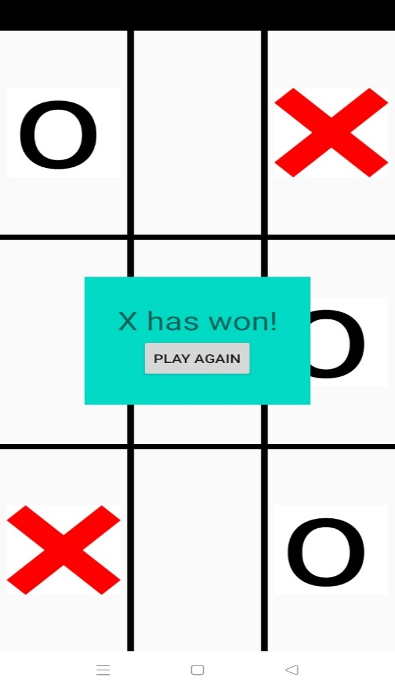

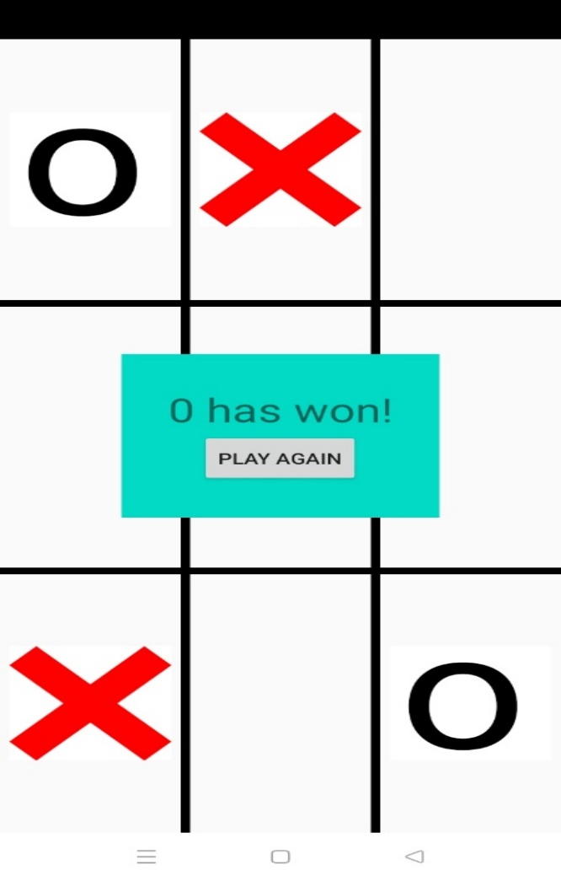

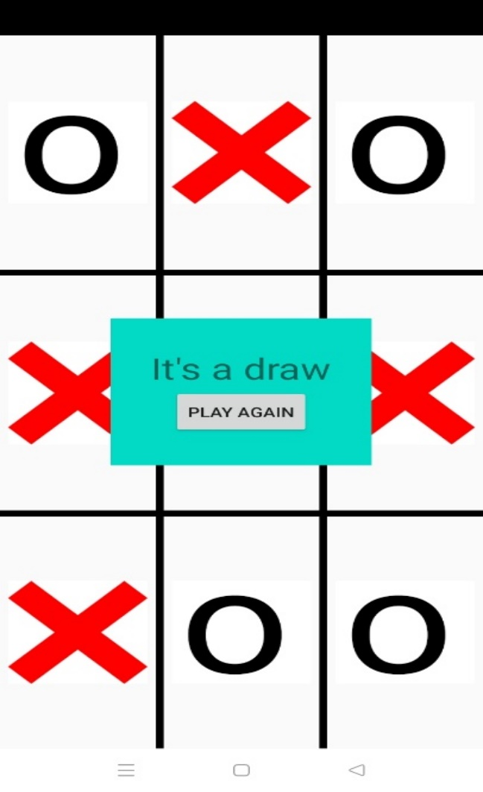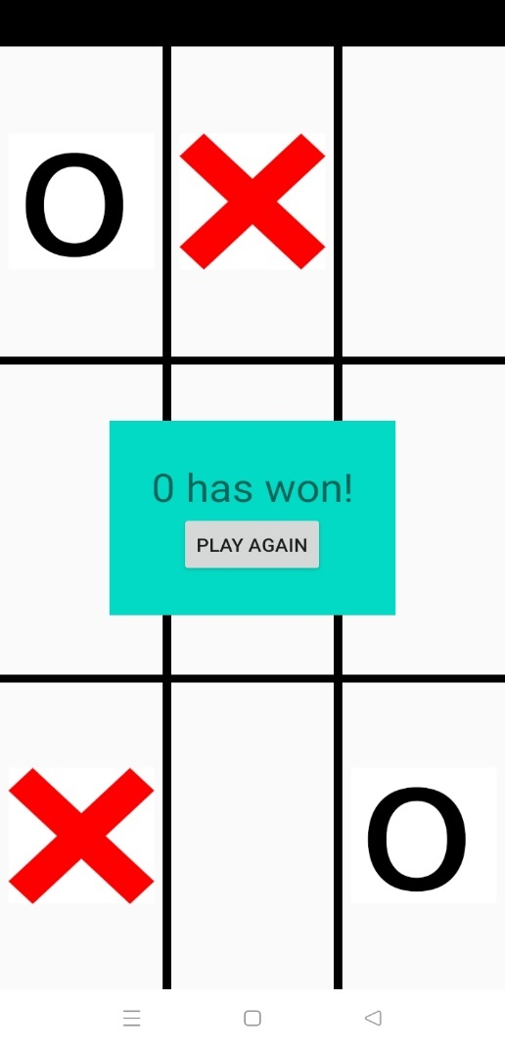

Conclusion:

Gaming become modern when played on tabs, mobiles etc.Enjoy with your friend, anytimw and anywhere.

References:

* <https://github.com/sandipapps/TicTacToe>
* [**https://www.codewithharry.com/videos/android-tutorials-in-hindi-5/**](https://www.codewithharry.com/videos/android-tutorials-in-hindi-5/)